**Offline PDF Analysis Suite - Technical Documentation**

Prepared by: Khushi Shrivas

Date: 08/06/25

**Table of Contents**

1. **Scope and Objectives**
   * Project Overview
   * Core Functional Scope
   * Target Capabilities
2. **System Architecture**
   * High-Level Architecture
   * Data Flow Pipeline
   * Component Interactions
3. **Technology Stack**
   * Core Technologies
   * Model Specifications
   * Configuration Management
4. **Implementation Challenges**
   * Challenge 1: Memory Management
   * Challenge 2: OCR Reliability
   * Challenge 3: Model Distribution
   * Challenge 4: Concurrent Processing
5. **Learning Outcomes**
   * Technical Skills Acquired
   * Problem-Solving Methodologies
   * Research and Development Insights
6. **Future Enhancements**
7. **Conclusion**

**1.** **Scope and Objectives**

**Project Overview**

The PDF Analysis Suite is an AI-powered document processing application that combines advanced natural language processing with GPU acceleration to provide intelligent document analysis capabilities. The system enables users to upload, process, summarize, query, and compare PDF documents- including their textual and tabular data- through an intuitive locally-hosted web interface, ensuring complete data privacy.

**Core Functional Scope**

* Multi-document Processing: Simultaneous handling of multiple PDF files with hybrid text extraction
* Advanced Table Extraction: Intelligently identifies and parses tabular data using layout analysis
* AI-Powered Analysis: Document summarization and question-answering using large language models
* Document Comparison: Intelligent difference detection between PDF documents
* GPU Acceleration: Hardware optimization for improved processing performance
* Interactive Interface: Web-based UI with real-time progress tracking

**Target Capabilities**

|  |  |  |
| --- | --- | --- |
| Feature | Description | Implementation |
| Text Extraction | Hybrid approach combining direct extraction and OCR | PyMuPDF + Tesseract |
| Table Extraction | Layout-aware extraction using both lattice and stream analysis methods. | Camelot + Pandas |
| Semantic Understanding | Context-aware document analysis | BGE embeddings + LLM |
| Question Answering | RAG-based natural language querying | Retrieval-Augmented Generation |
| Document Comparison | AI-enhanced difference detection | Difflib + semantic analysis |
| Performance Optimization | GPU acceleration with CPU fallback | CUDA + quantized models |

**2.** **System Architecture**

The system is designed with a modular, multi-layered architecture to separate concerns between the user interface, core logic, and data processing engines.

**High-Level Architecture**

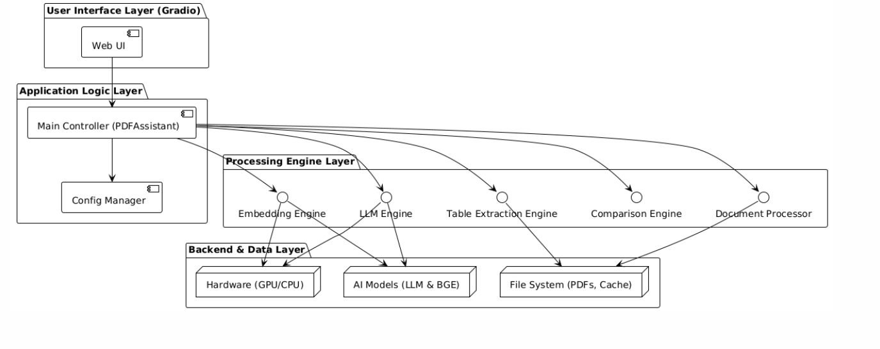

**Data Flow Pipeline**

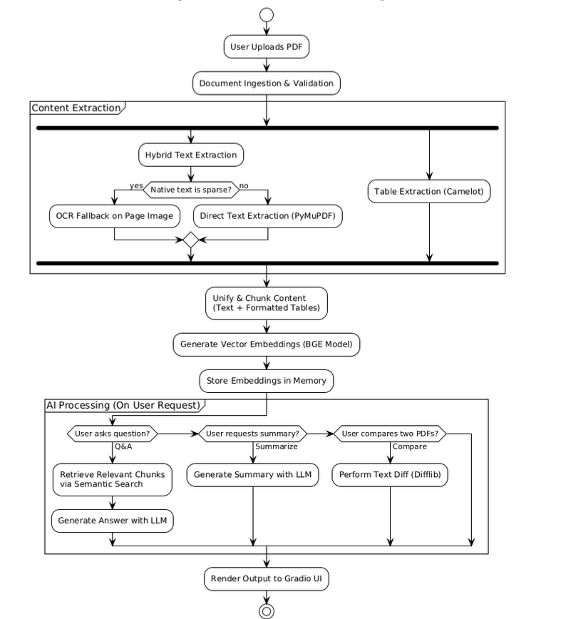

**Component Interactions**

|  |  |  |  |
| --- | --- | --- | --- |
| Component | Input | Output | Dependencies |
| Document Processor | PDF file path | Text chunks + Tables | PyMuPDF, Tesseract |
| Table Extraction Engine | PDF file path | Parsed pandas DataFrames and text | Camelot, Pandas, Ghostscript |
| Embedding Engine | Text chunks | Vector embeddings | BGE model, CUDA |
| LLM Engine | Prompts + Context | Generated responses | Llama-cpp, quantized model |
| Comparison Engine | Two PDF texts | Formatted differences | Difflib, HTML rendering |

**3.** **Technology Stack**

|  |  |  |  |  |
| --- | --- | --- | --- | --- |
| Layer | Technology | Version | Purpose | Key Features |
| Frontend | **Gradio** | **Latest** | **Web Interface** | **Multi-tab UI, real-time updates, queuing** |
| Runtime | **Python** | **3.8+** | **Core Logic** | **Threading, resource management** |
| Document | **PyMuPDF** | **1.23+** | **Native PDF Text & Metadata Extraction** | **High speed, low-level access** |
| Tables | **Camelot-py, Pandas** | **0.11+, 2.x** | **Advanced Table Extraction & Manipulation** | **Layout analysis, DataFrame integration** |
| OCR | **Tesseract + pdf2image** | **5.x, 1.16+** | **Scanned Document & Image-to-Text Conversion** | **Image preprocessing, language support** |
| AI/ML | **llama-cpp-python** | **0.2.x** | **Local LLM Inference** | **GGUF format, GPU offloading, quantization** |
| Embeddings | **BGE-Large-EN-v1.5** | **GGUF** | **Semantic Text-to-Vector Conversion** | **1024-dim vectors, high retrieval accuracy** |
| Compute | **PyTorch CUDA** | **2.x** | **GPU Acceleration** | **Memory management, CUDA kernels** |

**Model Specifications**

**Language Model: Hermes-2-Pro-Mistral-7B**

* Architecture: Transformer-based, 7B parameters
* Quantization: Q2_K (2-bit) for memory efficiency (~3.5GB)
* Context Window: 2048 tokens
* Capabilities: Text generation, summarization, QA

**Embedding Model: BGE-Large-EN-v1.5**

* Architecture: BERT-based encoder
* Precision: Float16 for GPU optimization
* Dimensions: 1024-dimensional vectors
* Performance: State-of-the-art retrieval performance on the MTEB benchmark

**Configuration Management**

class Config:

MAX_TOKENS_CHUNK = 1000 # Chunk size optimization

OCR_DPI = 200 # Image quality for OCR

EMBED_BATCH_SIZE = 4 # GPU memory optimization

LLM_N_CTX = 2048 # Context window

GPU_LAYERS = -1 # Full GPU utilization

USE_GPU = torch.cuda.is_available() # Dynamic detection

**4.** **Implementation Challenges**

**Challenge 1: Memory Management**

Problem: Large models (7B parameters) and multiple PDFs can exceed available memory.

Solution:

* Quantized models (Q2_K) reducing memory by 75%
* Dynamic GPU memory allocation with fallback to CPU
* LRU caching for frequently accessed operations
* Explicit garbage collection and CUDA cache clearing

# Memory optimization implementation

if Config.USE_GPU:

torch.cuda.empty_cache()

available_memory = torch.cuda.get_device_properties(0).total_memory

batch_size = min(Config.EMBED_BATCH_SIZE, available_memory // estimated_per_item)

**Challenge 2: Hybrid Content Extraction Reliability (Text & Tables)**

Problem: PDFs are notoriously inconsistent. A single strategy fails across documents with mixed content (native text, scanned images, complex table layouts).

Solution:

* Hybrid Text Extraction: Create a two-step process: attempt fast, direct extraction with PyMuPDF first. If text is sparse or absent, trigger page-level OCR with Tesseract as a fallback.
* Hybrid Table Extraction: Integrate Camelot, which uses both lattice (for tables with visible grid lines) and stream (for tables defined by whitespace) analysis
* Data Unification: Format both extracted text and table data into a consistent text-based representation before feeding them to the embedding model

**Challenge 3: Model Distribution**

Problem: Multi-gigabyte models require reliable downloading and caching.

Solution:

* HuggingFace Hub integration with resume capability
* Progress tracking with real-time user feedback
* Model integrity verification and corruption detection
* Persistent local caching to avoid re-downloads

**Challenge 4: Concurrent Processing**

Problem: Long-running operations block UI and degrade user experience.

Solution:

* Threading architecture with event-based cancellation
* Real-time progress reporting and status updates
* Resource isolation for different operations
* Thread-safe data structures with locking mechanisms

**5.** **Learning Outcomes**

**Technical Skills Acquired**

* AI/ML System Integration
* Model Optimization: Learned quantization techniques reducing memory usage by 75%
* GPU Programming: Mastered CUDA integration for 3-4x performance improvements
* RAG Implementation: Developed effective retrieval-augmented generation pipelines
* Embedding Systems: Built semantic search with cosine similarity and vector operations
* System Architecture Design
* Modular Design: Implemented clean separation of concerns across components
* Performance Optimization: Achieved efficient resource utilization through caching and batching
* Concurrent Programming: Developed thread-safe operations with cancellation support
* Error Handling: Built robust failure recovery and graceful degradation
* Document Processing Expertise
* Hybrid Extraction: Mastered a multi-engine approach for robust extraction of text and tables from diverse PDF formats
* OCR Integration: Implemented reliable optical character recognition with fallbacks
* Content Analysis: Developed semantic understanding of document structures

**Problem-Solving Methodologies**

* Performance Profiling: Systematic bottleneck identification and optimization
* Resource Management: Dynamic allocation based on hardware capabilities
* User Experience Focus: Real-time feedback and intuitive interface design
* Scalability Planning: Architecture designed for future enhancements

**Research and Development Insights**

* Model Evaluation: Benchmarking different quantization approaches for optimal performance
* Technology Integration: Successfully combining multiple complex AI frameworks
* Cross-platform Compatibility: Ensuring consistent behavior across different environments

**6.** **Future Enhancements**

**Short-term**

Processing Capabilities

* Advanced table extraction and complex structure recognition
* Chart/diagram analysis within documents
* Interactive Table Querying: Allow users to ask natural language questions directly about a specific displayed table.
* Streaming Processing: Process extremely large PDFs chunk-by-chunk to avoid loading the entire file into memory.

Performance Optimizations

* Multi-GPU distribution and cluster processing
* Streaming processing for large files

AI Enhancement

* Multi-modal processing combining text, images, and charts
* Conversational AI with multi-turn dialogue capability

Enterprise Features

* Cloud integration (AWS S3, Google Drive, OneDrive)
* Security: encryption, access control, audit logging
* RESTful API and multi-user collaboration

**Long-term**

Intelligent Ecosystem

* Knowledge management with relationship mapping
* Cross-platform deployment (mobile, desktop, cloud)

Advanced AI Integration

* Real-time adaptive learning models
* Deep semantic reasoning capabilities
* Kubernetes deployment with auto-scaling

**7.** **Conclusion**

**Project Impact**

The PDF Analysis Suite successfully demonstrates the practical application of cutting-edge AI technologies in document processing. By combining quantized large language models, GPU acceleration, and intuitive user interfaces, the project creates a powerful platform that makes advanced document analysis accessible to non-technical users.

**Technical Achievements**

* Hardware Optimization: Successful GPU acceleration with intelligent CPU fallback
* AI Integration: Effective combination of embedding models and LLMs for semantic understanding
* User Experience: Responsive interface with real-time progress tracking
* Hybrid Data Processing: Effectively extracts data from documents including tables.

**Learning Impact**

This project provided deep insights into:

* Advanced AI model deployment and optimization techniques
* System architecture design for resource-intensive applications
* Performance optimization strategies for GPU-accelerated computing
* User-centric design principles for complex technical systems
* Hybrid data Processing

**Future Potential**

The established architecture provides a solid foundation for:

* Enterprise-grade document processing solutions
* Specialized domain applications (legal, medical, academic)
* Large-scale document analysis and knowledge extraction
* Integration with broader AI-powered workflow systems

The PDF Analysis Suite represents a successful bridge between research-level AI capabilities and practical business applications, demonstrating the potential for democratizing access to advanced document intelligence tools.